**Introductory Wireshark Lab:**

**LAB # 05**



**Spring 2025**

Submitted by: **Mohsin Sajjad**

Registration No: **22pwsce2149**

Class Section: **A**

“On my honor, as student of University of Engineering and Technology, I have neither given nor received unauthorized assistance on this academic work.”

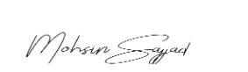

Student Signature: ______________

Submitted to:

**Dr. Yasir Saleem Afridi**

Month Day, Year (22 04, 2025)

Department of Computer Systems Engineering

University of Engineering and Technology, Peshawar

**CSE 303L: Data Communication and Computer Networks**

|  |  |  |  |  |
| --- | --- | --- | --- | --- |
| **Demonstration of Concepts** | **Poor (Does not meet expectation (1))**  The student failed to demonstrate a clear understanding of the assignment concepts | **Fair (Meet Expectation (2-3))**  The student demonstrated a clear understanding of some of the assignment concepts | **Good (Exceeds Expectation (4-5)**  The student demonstrated a clear understanding of the assignment concepts | **Score**  **30%** |
| **Accuracy** | The student mis-configured enough network settings that the lab computer couldn't function properly on the network | The student configured enough network settings that the lab computer partially functioned on the network | The student configured the network settings that the lab computer fully functioned on the network | **30%** |
| **Following Directions** | The student clearly failed to follow the verbal and written instructions to successfully complete the lab | The student failed to follow the some of the verbal and written instructions to successfully complete all requirements of the lab | The student followed the verbal and written instructions to successfully complete requirements of the lab | **20%** |
| **Time Utilization** | The student failed to complete even part of the lab in the allotted amount of time | The student failed to complete the entire lab in the allotted amount of time | The student completed the lab in its entirety in the al | **20%** |

**Credit Hours: 1**

**Objectives:**

1. Understand how network protocols work by observing real-time data exchanges.
2. Learn to use Wireshark to capture and analyze network packets.
3. Identify and study different protocol layers (Ethernet, IP, TCP, HTTP) in captured traffic.
4. Practice filtering packets to focus on specific protocol messages like HTTP.
5. Gain hands-on experience with network tools to explore how web traffic flows.
6. **CAPTURING PACKETS:**

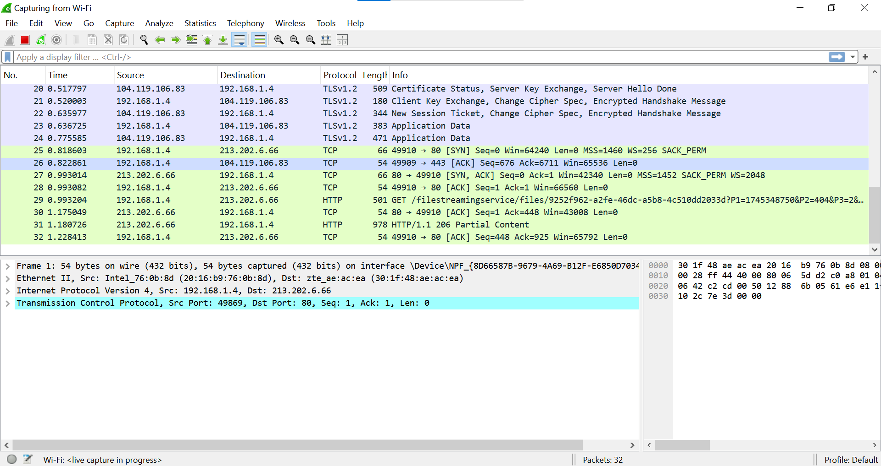

1. **Open a web browser** and visit this URL:  
   <http://gaia.cs.umass.edu/wireshark-labs/INTRO-wireshark-file1.html>

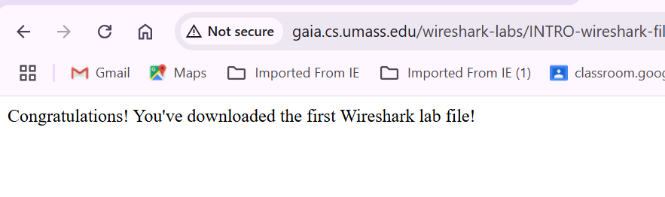

1. **Stop the capture** after the page loads.

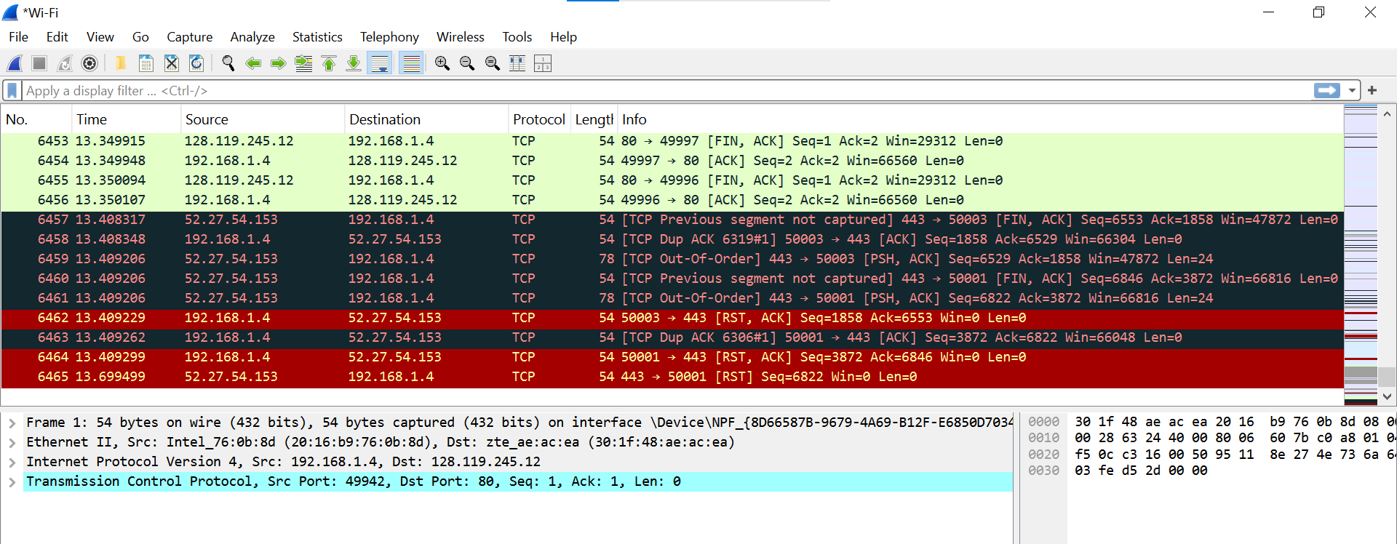

1. **Apply a filter** by typing http in the filter bar to only show HTTP traffic.

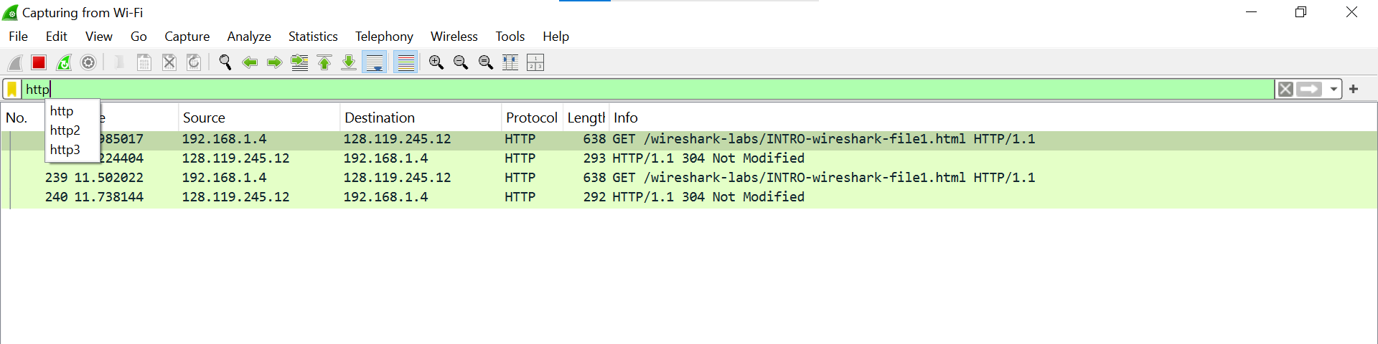

1. **Find the HTTP GET request** to the gaia.cs.umass.edu site and inspect its details.

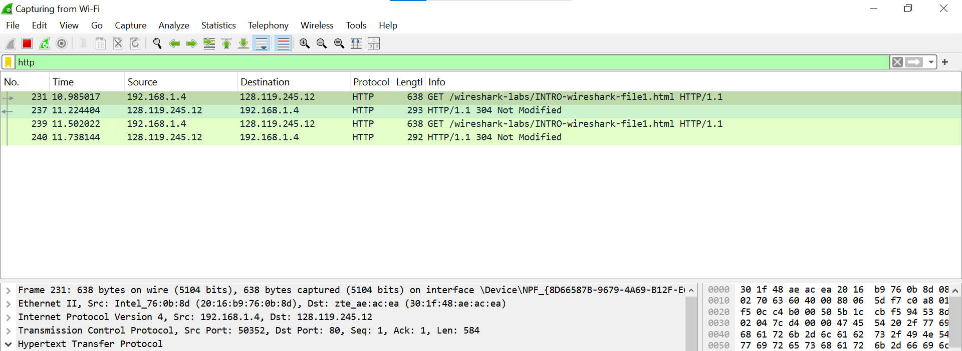

1. **Expand the HTTP section** and minimize other protocol layers (Ethernet, IP, TCP) to focus on the HTTP info.

